**EMERGENCY RESPONSE**

**& CONTINGENCY**

**PLAN**





**[ YOUR WATER SYSTEM NAME ]**

**WATER SYSTEMS**



This page is intentionally blank.

**Table of Contents**

**Prime Responsibilities**  1

**Emergency Response and Recovery Actions**  1

**Communication Checklist** 2

* RDN Priority Contacts 2
* Key Communication Options 2

**Emergency Contact Numbers** 3-8

**Site Addresses and Ph Numbers** 9

**Emergency Response *ACTION PLANS*** 10

* Backflow or Back Siphonage 10
* Bacteria Count (RDN Lab) 11
* Broken/Leaking Water Main 12
* Chlorine - High Levels 12
* Chlorination Failure 13
* Contamination of Source 13
* Drought Management Plan 14
* Flood Conditions 14
* Illness or Quarantine 15
* Isolate Water Treatment Plant 15
* Loss of Source 16
* Power Failure, Pump Failure 16
* Turbidity (Elevated) 17
* UV Failure 17

**Appendices**

* Boil Water Service Alert 19
* Boil Water Info for the General Public 20-32
* Unfit for Drinking (“Do Not Use”) Service Alert 33
* Water Quality Advisory Service Alert 34
* Water Service Interruption Service Alert 35
* Decision Tree for Responding to Turbidity Event 36
* Social Media Template 37
* Incident Response Form (internal) 38

**Maps - RDN Water Service Areas** 39

### Prime Responsibilities

* Provide safe drinking water.
* Provide potable water for sanitation purposes.
* Provide water for fire suppression.
* Prevent unnecessary loss of stored water.
* Restore the integrity of the entire water system as soon as possible.
* Maintain integrity and quality of supply.

### 

### 

### 

### 

### Emergency Response and

### Recovery Actions

* Analyze the type and severity of the emergency.
* Provide emergency assistance to save lives.
* Reduce the probabilities of additional injuries or damage.
* Provide situational reporting to appropriate agencies as required.
* Perform emergency repairs based on priority demand.
* Return system to normal levels (recovery).
* Evaluate response and preparedness plan.
* Revise plan as necessary.
* Provide maps, notices, and direction necessary for water recovery.

**Communication Checklist**

In an emergency it will be important to contact the key people shown below. This will help reduce confusion and assist in ensuring any important messaging is done so correctly and quickly.

**IF REQUIRED, CONTACT EMBC or Island Health BEFORE**

**MAKING THE FOLLOWING CONTACTS AS PER THE EMERGENCY PLANS**

**RDN Priority Contacts**

**MANAGER OF WATER SERVICES MURRAY W**

**(250) 668-41XX**

**WATER SERVICES PROJECT ENGINEER ROCKY C**

**(250) 268-54XX**

**DIRECTOR OF WATER/WASTEWATER SRVCS SEAN D**

**(250) 713-58XX**

**COMMUNICATIONS COORDINATOR REBECCA T**

**(250) 713-24XX**

**MANAGER OF EMERGENCY SERVICES ERICA B**

**(250) 668-21XX**

**Key Communication Options**

**Management Support**

* Contact Electoral Area Director
* Contact the local radio station and provide a brief message if public health and safety are at risk. Follow up with a press release and post on social media.

**Field Staff Support**

* Post notices on household front doors.
* Attach warning signs to existing Watering Restriction signs in each community.
* Put up roadside signage at the entrance to the community.

**Administrative Support**

* Provide information message on the RDN web site and social media.
* Review after-hours office and voice mail messaging.
* Provide notification to other RDN staff.

#### Emergency Contact Numbers

### Personnel Contacts

***NAME POSITION PHONE / CELL***

Heather D Chief Operator (250) 927-14xx

Dave W Utilities Technician II (250) 927-02xx

Brian H Utilities Technician III (250) 951-83xx

Brad L Utilities Technician III (250) 927-18xx

Lyndon j Utilities Technician II (250) 954-83xx

Greg R Utilities Technician II (250) 927-19xx

Shane P Utilities Technician II (250) 927-43xx

Jenna k Utilities Technician I (250) 228-35xx

Murray W Manager of Water Services (250) 668-41xx

Rocky C Project Engineer, Water Services (250) 268-54xx

Deb C Engineering Technologist (778) 674-17xx

Joe M Engineering Technician (250) 816-07xx

Dion K Bylaw Officer (250) 668-90xx

(*Emerg. Coord. Alternate- 24hrs)*

Chris B Bylaw Officer (250) 713-48xx

*(Emerg. Coord. Alternate- 24hrs)*

***After-Hours Emergency Contact Numbers***

Water Services (on-call) (800) 862-3429

Wastewater Services (on-call) (250) 729-6778

#### Electoral Area Directors

#### Electoral Area Director Phone E-mail Address

#### Chair Tyler Brown 250-755-44xx [tyler.brown@xxxx.ca](mailto:tyler.brown@xxxx.ca)

#### A Keith Wilson 250-722-33xx [keith.wilson@xxxxx.ca](mailto:keith.wilson@xxxxx.ca)

#### B Vanessa Craig 250-741-45xx [vanessa.craig@xxxxx.ca](mailto:vanessa.craig@xxxxx.ca)

#### C Charles Pinker 250-802-36xx [pinker.charles@xxxx.com](mailto:pinker.charles@xxxx.com)

#### E Bob Rogers 250-468-99xx [bob.rogers@xxxxxxx.ca](mailto:bob.rogers@xxxxxxx.ca%20%20)

#### F Leanne Salter 250-248-80xx [leanne.salter@xxxxxx.ca](mailto:leanne.salter@xxxxxx.ca)

#### G Lehann Wallace 250-951-53xx [lehann.wallace@xxxx.ca](mailto:lehann.wallace@xxxx.ca)

#### H Stuart McLean 250-240-22xx [stuart.mclean@xxxxx.ca](mailto:stuart.mclean@xxxxx.ca)

##### 

**Government Agency Contacts**

Ministry of Forests, Lands, and Natural Resource Operations (former Ministry of Environment) Nanaimo (800) 661-8773

RAPP Line (Report All Poachers & Polluters) Nanaimo (877) 952-7277

Department of Fisheries and Oceans Nanaimo (250) 754-0230

Emergency Management BC (EMBC) Victoria 1-800-663-3456

and Dangerous Goods Spills (formerly PEP)

##### Island Health (Environmental Health Officer) Parksville (250) 947-8222

Email HPES.Parksville@viha.ca

* Stacey Sowa- Nanoose Bay Peninsula, Englishman River (Rivers Edge), and San Pareil Water Systems
* Elizabeth Thomson- Surfside, Melrose, Whiskey Creek, Westurne Heights, and

Horne Lake Water Systems

* Shuja Awan- French Creek Water System

###### Island Health (Environmental Health Officer) Nanaimo (250) 755-6215

* Anthony Griffin- Decourcey Water System
* Jill Lucko- Descanso Bay and Rollo McClay Water Systems
* Murray Sexton, Public Health Engineer (250) 755-6293
* Dr. Paul Hasselback, Medical Health Officer (250) 739-6304/ (800) 204-6166

City of Parksville (250) 248-5412

* Chief Operator, Scott Churko (250) 927-18xx (cell)

Town of Qualicum Beach (250) 752-6921

* Chief Operator, Chris Stanger (250) 228-08xx (cell)

District of Lantzville (250) 390-4006

* Superintendent, Fred Spears (250) 713-09xx (cell)

North Cedar Improvement District (250) 722-3711

**Government Agency Contacts Cont’d**

Islands Trust Organization (Main office) Gabriola Isl (250) 247-2063

* Trustee Scott Colbourne Gabriola Isl (778) 679-11xx
* Trustee Kees Langereis Gabriola Isl (250) 247-82xx

**Emergency Services**

Hospital Nanaimo (250) 754-2141

Parksville (250) 248-2332 (Nan hospital)

Oceanside Ctr (250) 951-9550

Gabriola Clinic (250) 247-9922

Ambulance Nanaimo 911 or (250) 758-8181

Parksville 911 or (250) 248-3511

Police Nanaimo 911 or (250) 754-2345

Parksville 911 or (250) 248-6111

Gabriola Isl 911 or (250) 247-8333

###### Fire Department Parksville 911 or (250) 248-3242

Errington 911 or (250) 248-5601

Coombs-Hilliers 911 or (250) 752-2144

Nanoose Bay 911 or (250) 468-7141

Qualicum Beach 911 or (250) 752-6921

Dashwood 911 or (250) 752-5434

Cedar 911 or (250) 722-3122 Gabriola Isl 911 or (250) 247-5601

**Priority Services**

BC Hydro (Qualicum Beach number) (250) 752-8012 or

BC Hydro (Power Outages to Critical Infrastructure) (866) 693-7007

Telus (250) 811-2323 or

* Amarjit Mann cell 250-927-09xx (250) 741-77xx
* Mark Vonhagen cell 250-927-34xx

FortisBC (Terasen Gas) (250) 248-4880

Shaw Cable (Nanaimo) (250) 754-5571

CP Rail (800) 716-9132

French Creek Pollution Control Centre (250) 248-5794

Chlorine Manufacturer (ClearTech) (800) 387-7503

**Community Contacts**

###### 

###### Mosaic Forest Management (Emergency Number) (877) 437-8111

###### District 69 School Board Office (250) 248-4241

Nanoose Bay School (250) 468-7414

Nanoose Children’s Centre (250) 468-1784

Nanoose Place (250) 468-5339

Nanoose Post Office (250) 468-7722

Canadian Forces Base Nanoose (250) 756-5021 or 468-5004 or (250) 468-2260 (MP Stn-24hr)

Descanso Bay Reg Park- RLC Brad Ashdown (250) 228-00xx

Horne Lake Reg Park- RLC [bradashdown@xxxxxx.ca](mailto:bradashdown@xxxxxx.ca) (250) 228-00xx

**Excavation Services**

Shoreline Equipment (Doug) (250) 468-77xx or 755-95xx

Rite on Time Excavation & Trucking (Cody) (250) 927-16xx

Degnen Excavators (Gabriola Isl) (250) 247-88xx

**Electrical Contractors**

Raylec Power [servicerequest@raylecpower.ca](mailto:servicerequest@raylecpower.ca) (250) 400-4266

Canem Electric (250) 468-1887

Denmar Electric [info@dmel.ca](mailto:info@dmel.ca) (250) 758-8464

Ron Ruckman (Descanso Bay/Gabriola Isl) (250) 247-0050

**Other Services**

Plumbing Services (Maci Motor - Pump Repair) (250) 248-4423

JC Plumbing (Descanso Bay/Gabriola Isl) (250) 247-7574 or 713-6700

EPCOR (Parksville) (250) 951-2460

Sand and Gravel (Ozero) (250) 752-1482

Sand and Gravel (Lussier & Sons) (250) 468-9994

Sand and Gravel (DBL) (250) 248-3693

Mainroad Contracting Road Maintenance Hotline (877) 215-6006

Mainroad Contracting (Parksville) [midisland@mainroad.ca](mailto:midisland@mainroad.ca) (250) 586-8884

Mainroad Contracting (Nanaimo/Cedar) [rheaslip@mainroad.ca](mailto:rheaslip@mainroad.ca) (877) 215-6006

**Other Services**

Bureau Veritas (Water Testing Lab) (250) 385-6112

Pump Truck (Action Tank Service) (250) 248-3833

Pump Truck (Coast Environmental) (250) 390-5080

Pump Truck and Toilet Rentals (A-1 Septic) (250) 248-4438

Portable Washrooms (Coast Toilet Rentals) (250) 753-7552

Bulk water supply (Bay Water Hauling) (250) 802-3215

Bulk water supply (Island Water Hauling) (250) 363-6363

Bulk water supply (VIP Water Inc) (250) 748-7309

Summer Rain Water Delivery (Gabriola Isl) (250) 247-9136

Running Water Enterprises (Red Williams) (250) 947-5197

Drillwell Enterprises (250) 746-5268

Kalicum Drilling (250) 245-1220

Hot Earth Geothermal (Derek Tomlinson) (250) 713-3330

###### Bottled water supply (Water Pure & Simple) (250) 752-1373

Groess Environmental (Vac Truck) (250) 268-2160

Pipe Eye Video Inspection (250) 753-2550 or (888) 756-2033

McRae’s (250) 883-7867

Badger Daylighting (250) 217-2187

SPR Traffic Control (250) 655-5041

KMF Traffic Solutions (250) 668-0195

JSK Flagging (250) 618-0232

DOMCOR (888) 636-6267

Ace Flagging (250) 720-7620

**Suppliers**

###### Northstar Propane (Coombs) (250) 586-9660

###### Flocor (250) 758-1551

Fred Surridge (piping) (250) 954-0368

###### Four Star Waterworks (piping) (250) 954-3546

EMCO Water Works (250) 756-3344

Iconix Water Products (250) 746-8877

Andrew Sheret (Parksville) (250) 954-9997

Andrew Sheret (Nanaimo) (250) 758-7383

Sunbelt (Equipment Rentals) (250) 248-1100

###### Irritex Pumps and Irrigation – (pumps) (250) 248-7028

Windsor Plywood (miscellaneous building supplies) (250) 752-3122

Albertsons Hardware (miscellaneous building supplies) (250) 248-6888

Robinson Rentals (250) 753-2465

United Rentals (250) 758-3911

**Media Services**

Rebecca T, RDN Communications Coordinator (250) 713-24xx

Radio Station (CKWV) Nanaimo and Parksville (250) 758-1131

TV Station (CHEK) (250) 383-2435

Newspaper (PQ News and The Weekender) (250) 248-4341

Gabriola Sounder (250) 247-9337

**Site Addresses and Ph Numbers**

|  |  |  |  |
| --- | --- | --- | --- |
| **Site** | **Address** | **Phone Number** | **Hydro Meter #** |
| Surfside Pump House |  |  |  |
| San Pareil Pump House |  |  |  |
| San Pareil Well # 4 |  |  |  |
| French Crk Pump House |  |  |  |
| French Creek Well # 5 |  |  |  |
| French Creek Well # 6 |  |  |  |
| French Creek Well # 7 |  |  |  |
| French Creek Well #2, 4 |  |  |  |
| Decourcey Well |  |  |  |
| Eng. Riv. Well Site |  |  |  |
| Eng. Riv. Elec. Kiosk |  |  |  |
| Eng. Riv. Reservoir |  |  |  |
| Melrose Pump House |  |  |  |
| Whiskey Creek Res. |  |  |  |
| Whiskey Crk P. House |  |  |  |
| Whiskey Crk Well Site |  |  |  |
| Westurne Heights |  |  |  |
| Madrona Well # 4 |  |  |  |
| Madrona Pump House |  |  |  |
| Madrona Well # 8 |  |  |  |
| Nanoose Well #2 P.House |  |  |  |
| Beachcomber PRV |  |  |  |
| Nanoose Well #3 |  |  |  |
| Nanoose Well #4 |  |  |  |
| Nanoose Well # 5 |  |  |  |
| Nanoose Well # 6 |  |  |  |
| Fairwinds Well #3 |  |  |  |
| Fairwinds Well # 2 |  |  |  |
| Tippet Rd Well |  |  |  |
| Nanoose Water Plant |  |  |  |
| Anchor Booster Pump |  |  |  |
| Craig Bay Pumpstation |  |  |  |
| Craig Bay #2 Pumpstation (new) |  |  |  |
| Wallbrook Well # 1 |  |  |  |
| Descanso Reg Park Well |  |  |  |
| Rollo McClay Comm. Park |  |  |  |
| Horne Lake Reg. Park |  |  |  |

### Emergency Response *ACTION PLANS*

| Emergency  (Listed Alphabetically) | Actions | Contact |
| --- | --- | --- |
| Backflow or  Back Siphonage | * Notify Env. Health Officer * If microbiological contamination, notify users to boil water * If chemical contamination, notify users “Do Not Use” * Isolate the affected area * Use alternate supply if necessary (i.e. truck-in water to fill reservoir) * Verify integrity of distribution syst. * Check for cross connections * Check for pressure losses * Complete repairs * Purge and disinfect lines * Sample and re-sample | * Island Health * RDN Supervisory personnel |
| Bacteria Count  (RDN Lab) | * Notify Env. Health Officer * **If Total coliforms found**, verify integrity of treatment process * Verify chlorine residual present * Flush watermain in suspect area * Re-sample * **If E.Coli found**, post signs and/or deliver notices to boil water * Isolate the affected area * Increase disinfectant dosage in affected area * Flush watermains in affected area * Verify chlorine residual present * Verify integrity of distribution system * Check for cross connections * Check for pressure losses * Use alternate supply if necessary (i.e. truck-in water to fill reservoir) * Re-sample | * Island Health * RDN Supervisory personnel      * Communications Coordinator      * Electoral Area Director |
| Broken Water Main  (also Leaking Water Main) | * Isolate the affected area * Throttle back the water main but keep positive pressure * Prevent backflow into main * Notify Env. Health Officer * Notify local fire chief * Post notice on social media * Arrange alternate water supply if necessary * Obtain utility clearance for excav. * Arrange for traffic control * Notify users of interruption * Complete repairs * Swab and flush the repaired section * Sample to verify disinfection residuals * Take bacteriological samples * Clean up site, restore surfaces * Enter the repair in asset database | * Island Health * RDN Supervisory personnel * Electoral Area Director * Local Fire Chief * Communications Coordinator * Receptionists |
| Chlorine- High Levels | * Verify integrity of chlorinator * Reduce the chlorine dosing rate * Notify users of high chlorine level * Notify Env. Health Officer * Arrange for repairs * Post notice on social media * Flush distribution system, if necessary * Follow dechlorination procedure for water discharged near creeks * Verify chlorine residuals present * Arrange alternate water supply if necessary (i.e. bottled water) | * Island Health * RDN Supervisory personnel * Communications Coordinator |
| Chlorination Failure | * Shut off well pumps and monitor reservoir levels * Batch chlorinate in reservoir (if no UV present) * Arrange chlorinator repairs * Notify Env. Health Officer * If no chlorine residual in distribution system, notify users (use Boil Water Notice) * Post notice on social media * Arrange for alternate disinfection if necessary (i.e. trucking chlorine from another RDN site) * Arrange alternate water supply if necessary (i.e. bottled water) | * Island Health * RDN Supervisory personnel * Chlorinator Manufacturer |
| Contamination of Source  (Spills, Accidents, Vandalism) | * Shut down pumps * Verify source of contamination * Notify Env. Health Officer * Notify users “Do Not Use” * Contact local media * Post notice on social media * Arrange alternate source if necessary – i.e., bottled water * Contact environmental consulting firm (with P.Geo or P.Eng) to determine extent of contamination and plan for remediation | * Island Health * EMBC (Emergency Management BC) * RCMP if there has been vandalism * Ministry of Environment * RDN Supervisory personnel |
| Drought Management Plan | * Monitor local well levels, streamflow, prov. drought rating, and prov. wildfire rating * Review history, predict shortages * Promote conservation strategies * Post notices on social media * Maintain storage for fire flows * Implement watering restrictions * Reduce flows from all wells * Adjust chlorine dosing levels | * Island Health * EMBC (Emergency Management BC) |
| Flood Conditions | * **For well supplies**, ensure well casing stickup is over 200 yr flood level, and a surface seal in place * Monitor turbidity * **For surface water supplies**, monitor turbidity levels and continue treatment if <1NTU * If source water is compromised, shut off supply pumps * Notify Env. Health Officer * Notify EMBC * Notify users Do Not Use * Post notice on social media * Contact local media * Arrange alternate source if necessary – i.e., bottled water | * Island Health * EMBC (Emergency Management BC) * Ministry of Environment * RDN Supervisory personnel * Communications Coordinator |
| Illness or Quarantine | * Notify Env. Health Officer * Clean and sanitize work surfaces * Follow CDC health guidelines for self-quarantine if required * Use social distancing practices * Avoid sharing equipment, computers, keys, vehicles * Vary shifts if necessary * Administrative staff to work from remote location if possible * Keep at least 1 months’ worth of disinfection supplies and spare parts on hand in case of delivery delays or shortages * Employ multiple operators in each water system * Train all operators in all operational duties, in all water systems, where possible * Seek advice from senior operators and manager by phone | * Island Health * RDN Supervisory personnel * Emergency Ops Center (EOC) * Communications Coordinator * Employee and family resource programs |
| Isolate Water Treatment Plant | * Notify Env. Health Officer * Shut down water treatment plant * Close valve on Nanoose Road to bypass treatment plant * Arrange for alternate disinfection, if necessary * Post notice on social media * Call for repairs | * Island Health * Ministry of Environment * RDN Supervisory personnel * Local Fire Chief * Communications Coordinator |
| Loss of Source  (Loss Of Reservoir or  Supply Lines) | * Notify Env. Health Officer * Ensure pumps are shut off (to protect pump) * Notify users of interruption * Post notice on social media * Arrange alternate source (i.e. trucked-in water from another RDN water system * Arrange for temporary storage cistern * Call for repairs | * Island Health * Ministry of Environment * RDN Supervisory personnel * Local Fire Chief * Communications Coordinator |
| Power Failure | * Call BC Hydro. Ask how long? * Install back-up generators & fuel supply at each pumphouse * Use a portable back-up generator where necessary * Check on-site generators for effective operation & fuel supply * Notify Env. Health Officer * Notify users of interruption if necessary * Post signs and/or deliver notices * Post notice on social media * Arrange alternate source (i.e. trucked-in water from another RDN water system * Arrange for temporary storage cistern if necessary * Arrange alternate disinfection if necessary (i.e. batch chlorinate in reservoir) | * BC Hydro * Island Health * RDN Supervisory personnel * Local Fire Chief |
| Pump Failure | * Notify users of interruption * Call for repairs * Notify Env. Health Officer * Arrange alternate source (i.e. trucked-in water from another RDN water system | * Island Health * RDN Supervisory personnel |
| Turbidity (Elevated) | * Use Turbidity Decision Tree (attached on Page 36) * If source water has elevated turbidity, notify Env. Health Officer * Use alternate source if necessary (i.e. truck-in water from other RDN water system) * If elevated turbidity is within distribution system, flush affected area, notify Env. Health Officer * Monitor turbidity | * Island Health * RDN Supervisory personnel |
| UV Failure | * Maintain disinfection residual with chlorine * Check if UV unit is working and clean the UV bulb * Arrange for UV repairs * Notify Env. Health Officer * Use alternate source if necessary (i.e. bottled water) * Sample for disinfection by-products such as trihalomethanes * Issue a Water Quality Advisory if UV units are non-functional | * Island Health * RDN Supervisory personnel * UV Manufacturer * Communications Coordinator |

**APPENDICES**

Boil Water Service Alert 18

Boil Water Info for the General Public 19-31

Unfit for Drinking Service Alert 32

Water Quality Advisory Service Alert 33

Water Service Interruption Service Alert 34

Decision Tree for Responding to Turbidity Event 35

Social Media Template 36

Incident Response Form (internal) 37

Maps - RDN Water Service Areas 38

|  |  |
| --- | --- |
|  | *SERVICE ALERT* Date:___________________ |

## 

## BOIL WATER

**_______________ WATER SERVICE AREA**

**EFFECTIVE DATE:**

Please note that all water used for domestic purposes (drinking, cooking, etc.) should be boiled before consumption. The boiling should be at a rolling boil and for a minimum of two (2) minutes.

RDN Water Services staff are continually monitoring the water supply and will provide updates as they become available. Please watch for information updates at [www.rdn.bc.ca/service-alerts](http://www.rdn.bc.ca/service-alerts).

**For more information, please contact:**

Water and Utility Services

Regional District of Nanaimo

250-390-6560 or 250-248-4914

rcu@rdn.bc.ca



**BOIL WATER NOTICE INFORMATION FOR THE GENERAL PUBLIC**

**DURING A BOIL WATER NOTICE CAUSED BY:**

**INADEQUATE DISINFECTION**

This information is provided as a guide to help individuals reduce the risk of becoming ill from ingesting non-potable water. Individuals who follow these guidelines will greatly reduce their chance of becoming ill.

**What is a Boil Water Notice?**

A Boil Water Notice is a public announcement advising water system users that they should boil their tap water for drinking and other domestic purposes. It is a notice intended to protect the Publics’ health from waterborne infectious agents that could be present or are known to be present in the community’s drinking water supply.

**What is the difference between a Boil Water Notice and a Boil Water Order?**

A Boil Water Notice is a notice issued to the public as a health warning. In most cases it is the water supplier who notifies the public.

A Boil Water Order is legal document issued to the water supplier by the Health Authority requiring the water supplier to notify the public of a boil water notice.

**What are the health risks during a Boil Water Notice?**

The health risks are associated with ingesting water that contains microbiological agents that can cause disease. These pathogenic (disease causing) agents could include *Giardia, Cryptosporidia, E. coli, Campylobacter, Salmonella* and *Hepatitis A*. Boiling tap water for one minute is sufficient to destroy pathogens that could be present in the water.

There are numerous factors that influence whether a person becomes ill. First, there must be pathogens present in the water you consume. Not every glass of water is likely to contain pathogens. Even if the water you consume contains pathogens, those pathogens that are present must be viable. That is, they must be in a state where they can cause an illness and they must be present in large enough numbers to cause an illness. The number of pathogens needed to cause illness depends on the type of pathogen present, a person’s size, age, and immune status.

The incubation period (time for symptoms to develop) will vary depending on the type of pathogen. For example, Giardia (beaver fever) could take up to four weeks to develop symptoms whereas E. coli could take up to ten days and as little as two days. For more information on waterborne diseases go to the following BC Health File: <https://www.healthlinkbc.ca/>

Any persons believing that they are ill should see their doctor. Patients are sometimes requested to submit samples for laboratory analysis to assist in waterborne outbreak investigations.

It is important to note that Boil Water Notices are specific to microbiological threats. They are not appropriate to address threats from chemical contamination. Boiling chemically contaminated water will only result in the chemical becoming more concentrated or release the chemical into the air where it could be inhaled.

When there is a threat to a water supply from a chemical contaminated a more appropriate public health notice of “Do Not Drink the Water” would be issued.

**What am I trying to kill when I’m boiling the water?**

Boiling water is recommended to kill pathogenic microbes that may be present in contaminated water. Bacteria such as E. coli and Salmonella are killed rapidly at temperatures over 60°C and a temperature of 72.4°C for 1 minute is needed to inactivate cryptosporidium. *Hepatitis A* and *Norovirus* are rapidly inactivated at temperatures above 65°C.

Based on the above information there is no need to boil water for prolonged periods of time. Although heating water to boiling is not needed it is the only end point easily recognized by the public without the use of thermometers. It is therefore recommended that the public bring the water to a rolling boil for one minute to ensure that all pathogens have been inactivated.

One minute should be added to the above boiling times if the water is cloudy or highly colored to ensure proper mixing and that all pathogens have been exposed to the high temperature. When boiling water at altitudes above 2000m (6,500 ft), water should be boiled for 2 minutes.

**How can the water become contaminated?**

The water can become contaminated in a variety of ways.

Some of these include:

* Heavy rainfall can wash contaminants into the water source
* Accidental spills in the water supply
* Breakdown of the disinfection process
* Break in water supply mains
* Vandalism
* Connections within the water system between potable and non-potable piping.

**Is it necessary to boil all the water in the home during a boil water notice?**

No, it is not necessary to boil all your water. Water used for bathing, showering, laundry, toilet flushing and mopping of floors does not need to be boiled. During bathing, young children should be cautioned against swallowing the bath water or alternatively young children could be sponge bathed.

All other water should be boiled. Simply put, any water that has a chance of being ingested should be boiled. This would include water used for drinking, beverage concentrates, ice cubes, washing fruits and vegetables, or brushing teeth.

Severely immune-compromised individuals should always boil their tap water for the purposes above. See the link to BC Health Files below (updated in 2019).

<https://www.healthlinkbc.ca/healthlinkbc-files/disinfecting-drinking-water>

Infant formulas should always be prepared by using boiled tap water or bottled water that is boiled. See the link to Island Health below.

<https://www.healthlinkbc.ca/healthlinkbc-files/making-storing-formula>

Drinking water for pets including dogs, cats, birds and reptiles should also be boiled.

**How should tap water be boiled properly?**

Tap water should be boiled for at least one minute. Use any clean pot or kettle. Kettles that have automatic shut offs are acceptable.

**How should tap water be boiled properly? *(continued)***

Health Canada suggests that microwave ovens can also be used using microwave-safe containers but cautions against forming superheated water (water heated above its boiling point without the formation of steam). When using microwaves, Health Canada suggests inserting a glass rod, wooden or plastic spoon in the container to prevent forming superheated water.

After boiling, let the water cool by leaving it on the counter or in the refrigerator in covered containers. Once the water is boiled, it can be stored in food grade containers at room temperature or in the refrigerator.

Shaking the water in the container or pouring the water between two containers and/or adding a pinch of salt can bring back flavor after boiling.

**Are there alternatives to boiling water?**

Yes, there are. Although there are alternatives, not all of them will be feasible or practical in all situations. In part, it will depend on how much water you need and what you need it for. Safe alternatives to boiling water include:

* Using commercially prepared bottled water
* Obtaining water from an approved source that is not on a boil water notice, or
* Using bleach to disinfect small quantities of tap water. See the following chart or website for a guide to using bleach.

<https://www.healthlinkbc.ca/healthlinkbc-files/disinfecting-drinking-water>

Disinfection using unscented household bleach (5% chlorine) works best with warm water. Add bleach to the water, shake or stir for thorough mixing and then let it stand for at least 30 minutes before drinking.

|  |  |
| --- | --- |
| Gallons of water to disinfect  (equivalent shown in brackets) | Amount of Household bleach (5%)  to add* |
| 1 gal. (4.5 litres) | 2 drops (0.18 mL) |
| 2 ½ gal. (10 litres) | 5 drops (0.4 mL) |
| 5 gal. (23 litres) | 11 drops (0.9 mL) |
| 10 gal. (45 litres) | 22 drops (1.8 mL) |
| 22 gal. (100 litres) | ¾ teaspoon (4 mL) |
| 45 gal. (205 litres) | 1 ½ teaspoons (8 mL) |
| 50 gal. (230 litres) | 1 ¾ teaspoons (9 mL) |
| 100 gal. (450 litres) | 3 ½ teaspoons (18 mL) |
| 220 gal. (1000 litres) | 8 teaspoons (40 mL) |
| 500 gal. (2200 litres) | 6 tablespoons (90 mL) |
| 1000 gal. (4550 litres) | 6 ½ ounces or 12 tablespoons (180 mL) |

A slight chlorine odour should still be noticeable at the end of the 30-minute waiting period if you have added enough bleach. If not, repeat the dosage and allow the water to stand an additional 15 minutes. If the water has too strong a chlorine taste, allow the water to stand exposed to the air for a few hours or pour it from one clean container to another several times.

The disinfection action of bleach depends as much on the waiting time after mixing as to the amount used. The longer the water is left to stand after adding bleach, the more effective the disinfection process will be.

**NOTE: Bleach does not work well in killing off *Cryptosporidium* parasites.**

The amount of bleach needed to kill *Cryptosporidium* makes the water almost impossible to drink. If *Cryptosporidium* is in the water, boiling is the best way to ensure that the water is safe to drink.

**I have my own water treatment device do I still need to boil my water?**

If the device is designed to improve taste or reduce odour such as an activated carbon filter the answer is **YES** you should still boil your water.

If the device is designed to improve the chemical quality of the water such as reducing the iron content then the answer is **YES** you should still boil your water.

If the device is designed to improve water that is already potable the answer again is **YES** you should still boil your water.

There are numerous filters on the market designed to remove microorganisms and particulates. Most of these filters are not capable of removing viruses. Therefore, you should boil your water if you have a unit that cannot remove viruses.

If the device is designed to disinfect (destroy pathogens) water such as in an ultraviolet light (UV) disinfection unit you **might not** need to boil your water. There are numerous ultraviolet units; some are designed to disinfect raw water and some are designed to disinfect water that has already been disinfected at a central facility. For example, if the unit is classified by the National Sanitation Foundation (NSF) as meeting NSF Standard 55 Class A, it is designed to disinfect raw water. However, if the water within the distribution system is too turbid or cloudy, even a UV unit meeting NSF Standard 55 Class A may not work properly and you should still boil your water.

Reverse osmosis (RO) units are designed to filter water at the molecular level and should provide water that is free of pathogens. Thus, you **do not** have to boil your water if you have a reverse osmosis water treatment device.

There are many types of units on the market each designed to address specific water quality issues. It is recommended that you check with the unit’s manufacturer to know exactly what your unit can do.

**Can I purchase water from vending machines?**

It depends on how the water is treated. Local vending machines that use local water would only be acceptable if the vending machine can kill pathogens that might be present in the water. Check with the store or manufacturer to see if the unit is capable of providing water that is safe to drink.

Warning signs should be posted on vending units that are not capable of providing safe water. Alternatively, the machine should be turned off.

**Are there any people or groups of people at higher risk?**

Yes. These people include any individual whose immune system is not fully developed or whose immune system is under stress such as infants, the elderly, immune compromised individuals and individuals already suffering from an illness. For more information go to the following BC Ministry of Health websites:

BC Health File: weakened immune systems

<https://www.healthlinkbc.ca/healthlinkbc-files/disinfecting-drinking-water>

BC Health File: preparing infant formula

<https://www.healthlinkbc.ca/healthlinkbc-files/making-storing-formula>

**Boil water or provide an alternative safe supply of water that is used for:**

* Drinking purposes- This includes all beverage concentrates such as fruit juice and iced tea
* Food preparation- This includes washing of fruits and vegetables
* Food contact surfaces

**Boil water or provide an alternative safe supply of water that is used for: *(continued)***

Food contact surfaces are all those surfaces that food comes into contact with during the food preparation process. These surfaces include counter tops, cutting boards and chopping blocks. Food contact surfaces should be washed with clean water and then sanitized using an acceptable sanitizing agent. Sanitizing agents for food contact surfaces include bleach (12-15 mL of 5% bleach per litre of water), iodophors, quaternary ammonia compounds or hydrogen peroxide (3% solution).

* Oral hygiene (brushing teeth)
* Infant formula; see BC Health File; preparing infant formula at

<https://www.healthlinkbc.ca/healthlinkbc-files/making-storing-formula>

* Ice making

It is important to note that freezing does not destroy most pathogens. Bacteria and viruses can survive in frozen products for long periods of time. Discard any ice made from contaminated or potentially contaminated water.

**Hand washing**

Using warm water and soap should be sufficient. Applying a hand sanitizer after washing with tap water would add an extra barrier of protection.

**Dishwashing by hand**

Dishes washed by hand should be sanitized for two minutes in a separate sink using a bleach solution (2 mL of bleach per litre of water) after the dishes have been washed and rinsed. The dishes should then be left to **air dry** prior to being used. Attempting to wash and sanitize dishes in the same sink at the same time is not recommended because soap, grease and food particles interfere with the sanitizing process.

**Mechanical dishwashers**

Most residential home-style dishwashers do not provide a high enough temperature to kill all pathogens. Dishwashing units that reach 82 degrees Celsius (180 Fahrenheit) for twelve seconds (or an equivalent time-temperature relationship) during the final rinse cycle will destroy pathogens.

To optimize the disinfection process while using a residential dishwasher you should consider:

1. Using the highest temperature setting possible.

2. Running dishes through the dishwasher twice.

3. Sanitizing dishes afterwards in a sink containing a weak bleach solution(see dishes washed by hand above).

4. Letting the dishes air dry prior to use

**Fruit and vegetable washing**

Thoroughly wash all produce with potable water especially those that are going to be eaten raw. This is a common sense practice that should be applied even when there is no public boil water notice.

**Coffee Machines**

Coffee machines usually produce water around 70 to 80 degrees Celsius, which is sufficient to destroy pathogens. However, a sufficient amount of time is needed to ensure that all harmful organisms are destroyed. Therefore, let the coffee stand for at least five minutes before drinking.

**Home canning**

To be safe, postpone home canning until the boil water notice has been rescinded.

**Beer and wine making**

To be safe, postpone beer and wine making until the boil water notice has been rescinded.

**When will the Boil Water Notice be rescinded?**

Only when the water supplier can provide potable water will the Health Authority rescind the Boil Water Notice. Once or more of the following usually achieves confirmation that the water is once again safe to drink.

These include:

* Identifying and fixing the source or sources of the problem,
* Implementing procedures to eliminate or reduce the chance for reoccurrence
* Performing water quality tests
* Flushing and disinfecting distribution lines and water storage facilities

**Precautions to consider when the Boil Water Notice is lifted**

* Flush all water-using fixtures for 1 minute
* Run cold-water faucets and drinking fountains for 1 minute before using water
* Drain and flush all ice-making machines in your refrigerator
* Run water softeners through a regeneration cycle
* Drain and refill hot water heaters set below 45 deg C (normal setting is 60 deg C)
* Change any pre-treatment filters (under sink style and refrigerator water filters, carbon block, activated carbon, sediment filters, etc.)

**Can I speak to a person in Public Health if I have a question about the Boil Water Notice?**

Yes you can. For further information contact Island Health

Officers at the following locations:

* Victoria ph. 250-519-3401
* Nanaimo ph. 250-755-6215
* Parksville ph. 250-947-8222
* Courtenay ph. 250-331-8518
* Island Health Office 6475 Metral Drive, Nanaimo, BC
* Island Health Office 489 Alberni Hwy, Parksville BC

After hours Medical Health Officer on call is 1-800-204-6166.

**Additional information can be found at the following BC, Canadian and US websites. These are:**

BC Health File: How to disinfect drinking water

<https://www.healthlinkbc.ca/healthlinkbc-files/disinfecting-drinking-water>

BC Health File: Weakened immune systems and water-borne infections

<https://www.healthlinkbc.ca/healthlinkbc-files/preventing-water-borne-infection>

BC Health File: Drinking Water Health Topics

<https://www.healthlinkbc.ca/>

BC Health File: Cryptosporidiosis

<https://www.healthlinkbc.ca/healthlinkbc-files/cryptosporidium-infection>

BC Health File: Giardiasis

<https://www.healthlinkbc.ca/healthlinkbc-files/giardia-infection>

US EPA how to boil water and use bleach

<https://www.epa.gov/ground-water-and-drinking-water/emergency-disinfection-drinking-water>

US Centre for Disease Control; preventing cryptosporidiosis infection

<https://www.cdc.gov/parasites/crypto/gen_info/prevention-general-public.html>

US Centre for Disease Control; Giardia fact sheet

<https://www.cdc.gov/parasites/giardia/>

US Centre for Disease Control; Drinking bottled water

<https://www.cdc.gov/healthywater/drinking/bottled/>

US Centre for Disease Control; Private Water Systems

<https://www.cdc.gov/healthywater/drinking/private/>

**Information sources for developing this package includes**

* BC Ministry of Health
* Health Canada
* Alberta Environmental Health
* Washington State Department of Health
* BC Centre for Disease Control
* US EPA (Environmental Protection Agency)
* US Center for Disease Control
* NSF (National Sanitation Foundation)
* DWO (Drinking Water Officer’s) Guide

|  |  |
| --- | --- |
|  | *SERVICE ALERT* Date:___________________ |

## 

## WARNING

**_______________ WATER SERVICE AREA**

**EFFECTIVE DATE:**

**This water is considered UNFIT for drinking or domestic use.**

**For more information, please contact:**

Water and Utility Services

Regional District of Nanaimo

250-390-6560 or 250-248-4914

rcu@rdn.bc.ca



|  |  |
| --- | --- |
|  | *SERVICE ALERT* Date:___________________ |

## 

## WATER QUALITY ADVISORY

**_______________ WATER SERVICE AREA**

**DATE:**

**LOCATION:**

**ISSUE:**

The Regional District of Nanaimo wishes to notify you of the following:

(occurrence, possible taste/odour concerns, steps to take)

__________________________________________________________

__________________________________________________________

__________________________________________________________

__________________________________________________________

**For more information, please contact:**

Water and Utility Services

Regional District of Nanaimo

250-390-6560 or 250-248-4914

rcu@rdn.bc.ca



|  |  |
| --- | --- |
|  | *SERVICE ALERT* Date:___________________ |

## 

## WATER SERVICE INTERRUPTION

**_______________ WATER SERVICE AREA**

**DATE:**

**LOCATION:**

**HOURS:**

Please note that water service will be temporarily interrupted while improvements to the water system are being made. The above time period is not definite, and the RDN will endeavor to keep you in service as long as possible and have the water back in service as quickly as possible after the initial shutdown occurs.

When service is resumed, the water may be discoloured. This is due to disturbed deposits in the pipes and is not harmful. The RDN is not responsible for any damage resulting from interrupted service.

**For more information, please contact:**

Water and Utility Services

Regional District of Nanaimo

250-390-6560 or 250-248-4914

rcu@rdn.bc.ca



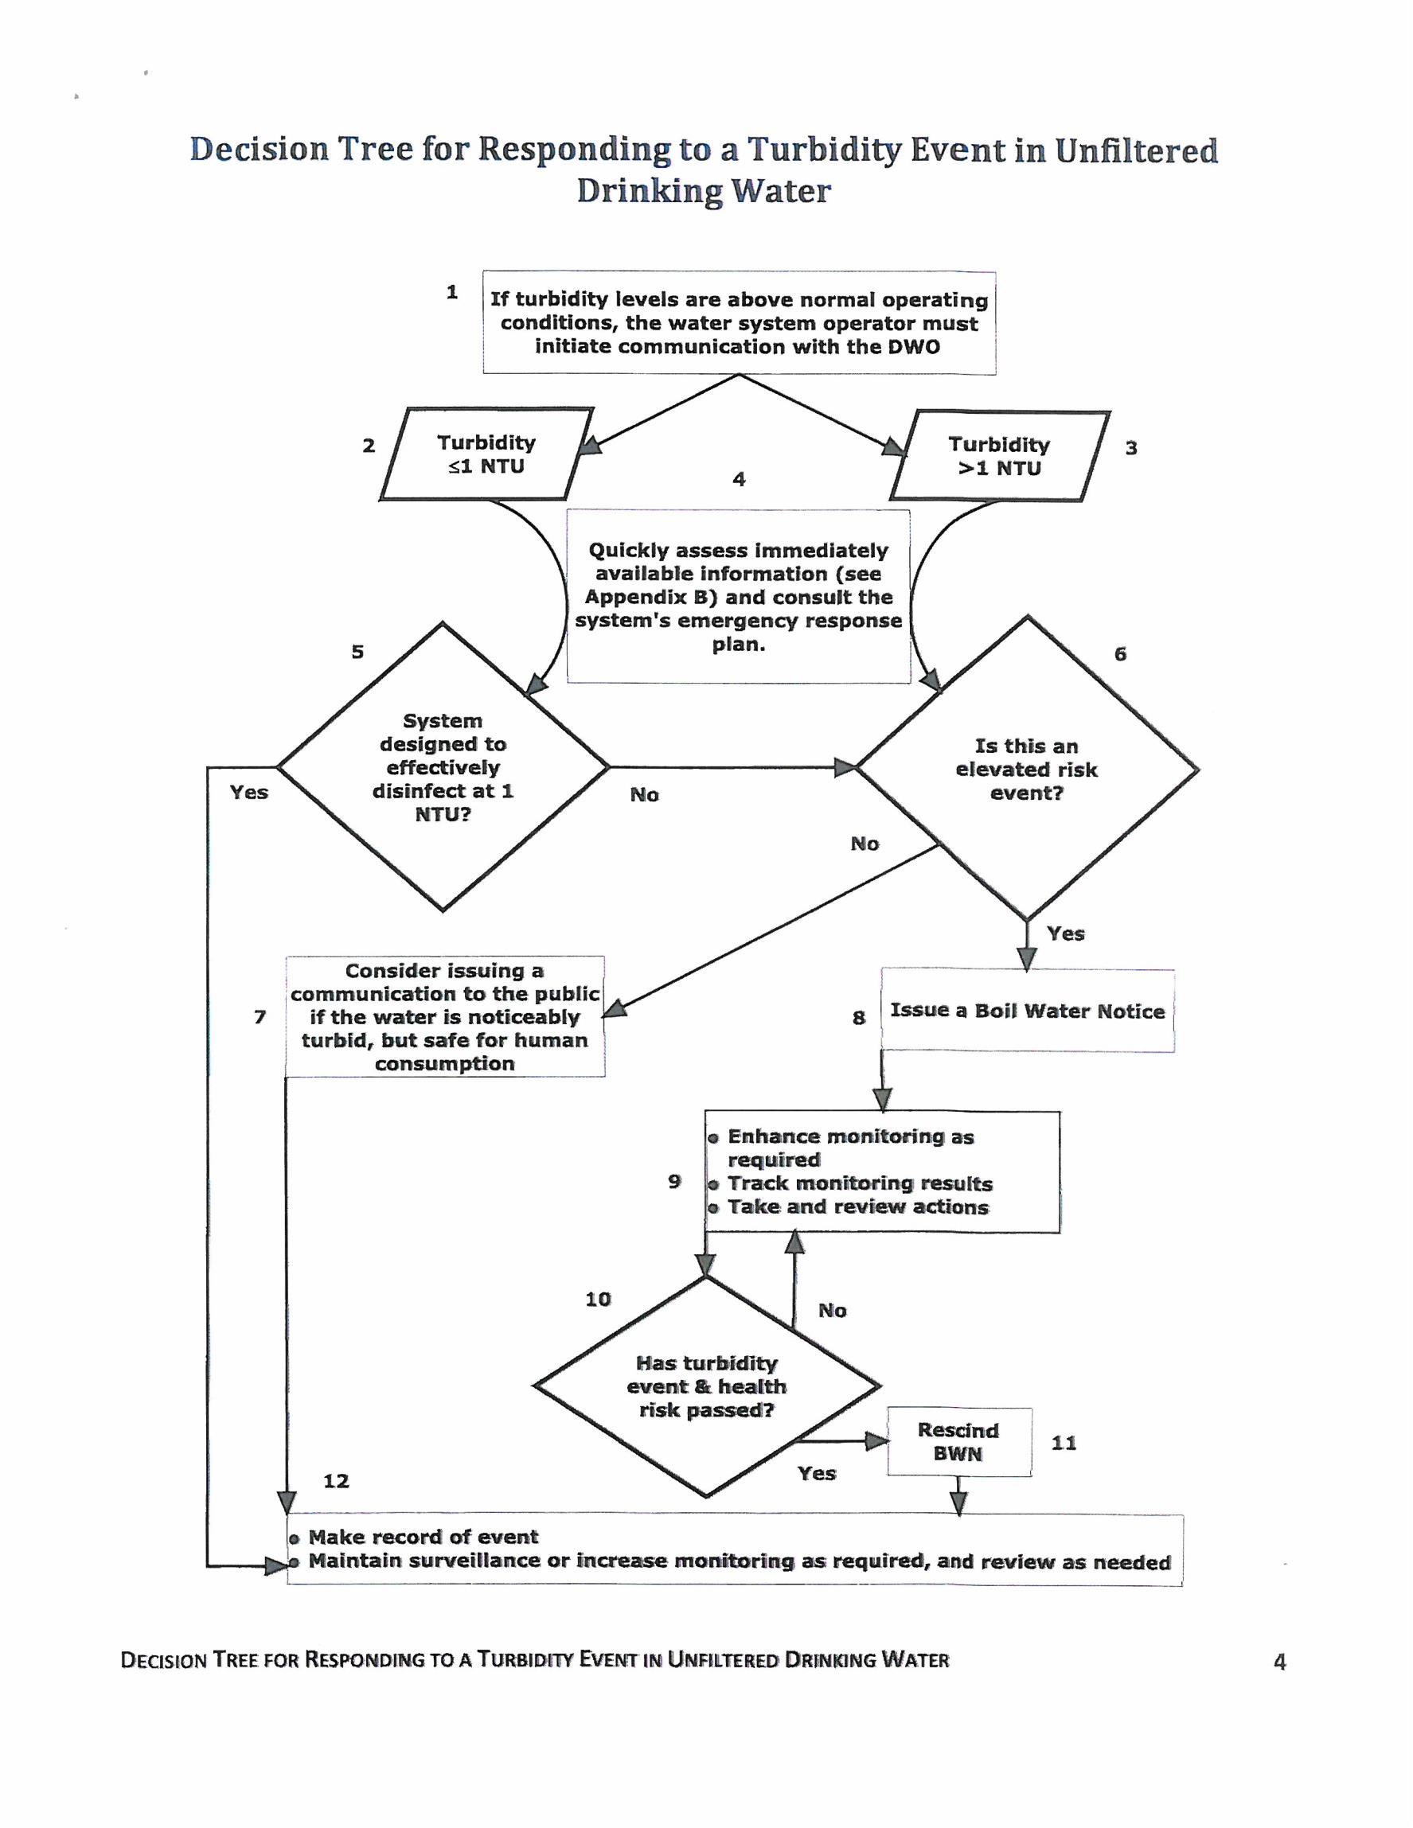

**Social Media Template**

**Facebook**

*Regional District of Nanaimo*

*(a Page, not a Person)*

State the facts: what is the event/issue, date, time, and how the issue is being addressed. Include a photo if possible, and reference the RDN website. Examples:

* *A large watermain break occurred early this morning on Collingwood Drive in Fairwinds. The break has been under control since about 7:00am, however homes at higher elevations will experience low pressures and possibly some air in their line for the next few hours. RDN operators are working to restore full water service as quickly as possible. When service is resumed, the water may be discoloured or have air in the lines. Drawing water from your outside tap for a moment will help clear your own service line of air, and minimize disruption to the fixtures in your home. The water is disinfected with chlorine, even under emergency conditions, and is safe to drink. A follow-up message will be posted later today when the repair is complete.*
* *The RDN will be flushing watermains in the French Creek (Sandpiper) Water Service Area from October 3 to 5, 2018. Customers may expect a temporary disruption of service, intermittent drops in water pressure, or discolouration of water between the hours of 8:00am and 4:30pm for this water system. For further details please visit* <https://rdn.bc.ca/service-alerts>*.*

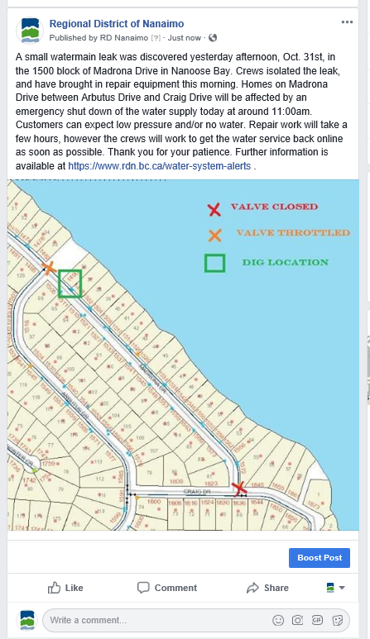**Twitter**

*#RDNanaimo*

State the facts, as above. Include a photo, and reference the RDN website.



**Instagram**

*@RDNanaimo*

Post a photo and reference the RDN website.

**Incident Response Form**

**(internal)**

Fill out the following information as completely as possible, and forward to the Manager of Water Services within 24 hours of the incident.

***TAKE PHOTOS!***

|  |  |
| --- | --- |
| Responding Operator: | Date: |
| Incident Name: | |
| CALLER INFORMATION | |
| Date Call Received: | Time Call Received: |
| Caller’s Name:  Phone #: | Address: |
| ACTIONS TAKEN (Operator actions, isolate, repair, cleanup) | |
|  | |
| INCIDENT DESCRIPTION (Time, location, cause) | |
|  | |
| NOTIFICATIONS (Manager, Communications Coord., Media) | |
|  | |
| MANAGER FOLLOW-UP | |
| Extent of Damage:  Costs Involved:  Feedback from Community: | |
| Additional Procedures Required:  Additional Follow-up Required: | |

File a paper copy of this form in RCU Water/Sewer Service Area folder (i.e. 5500-22-NBP-01)

**MAPS**

**[ YOUR WATER SYSTEM NAME(S) ]**

Madrona Pt/Wall Beach Neighbourhood Map 1

Fairwinds Neighbourhood Map 2

Arbutus Park/Garry Oak Dr Neighbourhood Map 3

West Bay/Red Gap Neighbourhood Map 4

Driftwood Neighbourhood/Claudet Rd Map 5



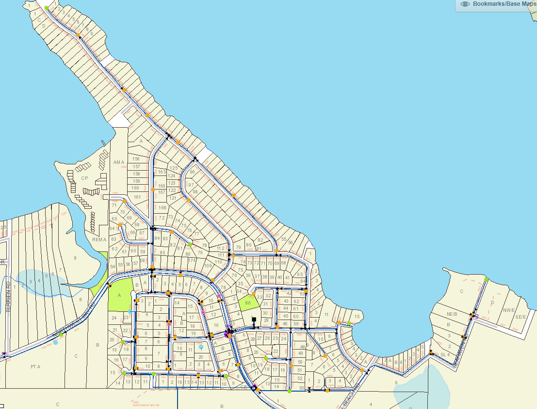

**MAP 1 MADRONA PT/WALL BEACH**