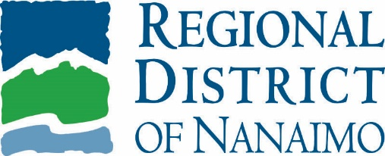 | service alert  March 14, 2020

Electrical Issue Forces Ravensong Aquatic Centre to Close
An electrical issue occurred at Ravensong Aquatic Centre on Saturday night, March 14, and the facility will need to be closed until the issue can be fixed. We will provide an update as soon as we can.

The closure is not related to COVID-19 which the RDN is actively monitoring.

For more information, please contact:
Recreation and Parks
Regional District of Nanaimo
250-752-5014
recparks@rdn.bc.ca

For media inquiries, please contact:
Christina Gray
Regional District of Nanaimo
250-390-6502
cgray@rdn.bc.ca

